Pandora-A world of wonder and mystery
4.4 million light years away from Earth is alpha centorie A Pandora’s sun. Pandora is one of the many moons orbiting the planet Polyphemus.
Due to it’s toxic atmosphere humans cannot breath there.
Tropical rainforests cover most continents of Pandora.
There’s a wide-veriety of animals on Pandora all dangerous and inspiring.
Most animals including the winged creatures of the sky are Hexapods (six limbed), except the humanoid Na’vi.
Now lets take a look at two of the alien creature types on Pandora. 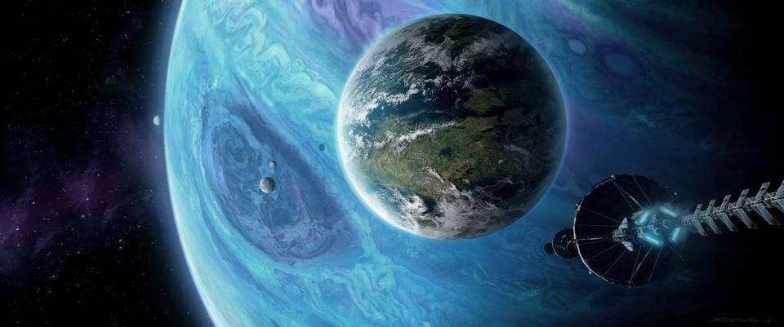
This Photo by Unknown Author is licensed under CC BY-NC

The Na’vi
The Na’vi’s height is between 2.5-3.9 meters tall. The Na’vi is an omnivorous species. They eat meat as demonstrated by pronounced canines but have also been seen to forage, demonstrating their consumption of plant and other produce. Because the Na’vi only have four fingers on each hand their counting system is reduced to counting in eights.

This Photo by Unknown Author is licensed under CC BY-SA-NC

The Direhorse
The Direhorse is a fierce black alien like creature that is modelled on a horse well turned into a strange alien. The Direhorse is an heroic creature that can be tamed by the Na’vi. They are beautiful and graceful creatures. This animal is easily startled and when all six of his legs are working together in unison, can run up to speeds of around ninety-five kilometres per hour.

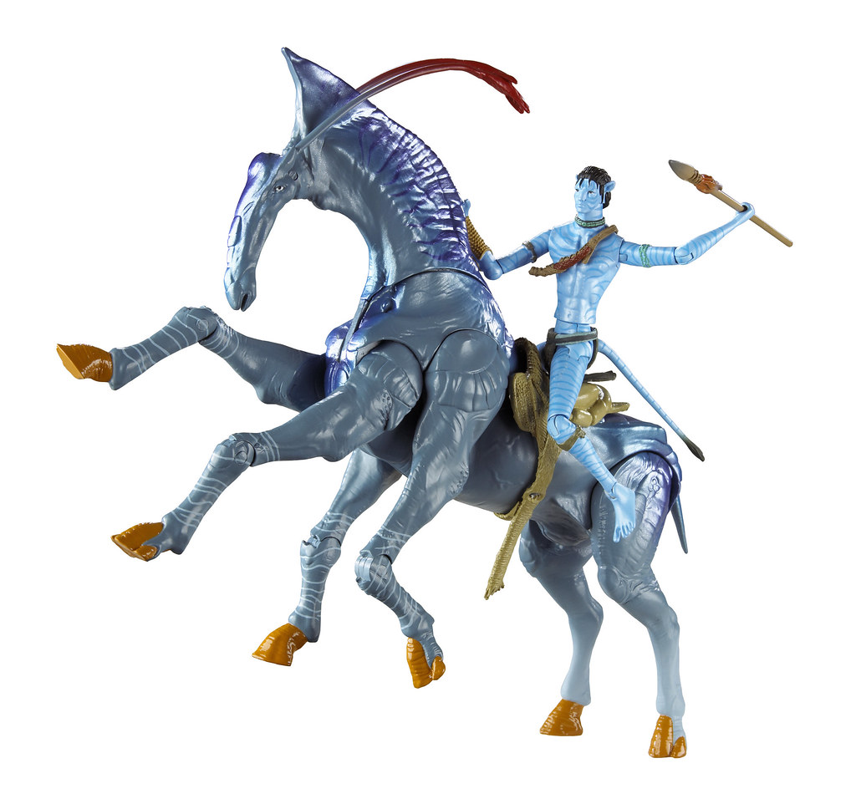
This Photo by Unknown Author is licensed under CC BY
Written by Blake Cooke completed on 08/01/2021

