Class 3 Home Learning Spring Term 1st half week 4
Hello Class 3. I hope you are all well and keeping safe. Thank you once again for joining me on the live lessons. This week I will be doing live English lessons on Google classroom daily at 9:30. It’ ll be great to see you all! There is also a brief Parent meeting on Thurs at 1:30 (if you are able to attend) or please e mail or call me if you need to chat. Many thanks for your support.
Here is your home learning for this week…
- Daily reading 20 mins daily
- Rockstars 20 mins daily
- Remember to log your daily reading.
- Daily PE – Keep going with your Joe wicks workout!
Eng On-line live lessons. Our focus will be poetry –I have found 2 poems to help us. I will post any PowerPoints or scaffolds on the class stream for you to use.
Eng task – can you research and find a river poem that you like? Read it, try and learn and perform it.
Maths focus fractions
Y5 I have sent you a video link. Follow this link for fractions. There are also daily question sheets.
https://whiterosemaths.com/homelearning/year-5/spring-week-3-number-multiplication-and-division-2/
Year 6 I have sent you a video link. Follow this link for fractions. There are also daily question sheets.
https://whiterosemaths.com/homelearning/year-6/week-8-number-fractions/

Y4 I have sent you a video link. Please follow the video. There are also daily question sheets.
https://resources.whiterosemaths.com/resources/year-4/spring-block-3-fractions/
For IXL fractions please see:
Y4 You can choose activities from Y1 to Y 10
Y5 Try T1 T2 T 3
Y6 Try J1 J2 J3

Art
In art we are still making pencil cases!
I ve attached more slides to help you with stitching an opening and closing for your pencil case. There is still felt for you at school to be collected if you would like it.
Art activity
We are studying local churches in RE and have sketched a local Dartmouth church for a display. Have a go at sketching and shading – I d love to see your work.
You could also use Purple Mash 2paint a picture
Science – Our focus this week is to continue with forces and air resistance. We will be looking at forces on aircraft. I ve attached a PowerPoint for you to look at. It would also be useful to look at clips of the red Arrows (see links below)
Introduction to the Red Arrows: http://news.bbc.co.uk/1/hi/uk/8355531.stm
Plymouth air display: http://news.bbc.co.uk/1/hi/england/8236895.stm
New learning - pushes and pulls act on an aircraft during flight. These are:
• forward thrust from the engine
• rearward drag caused by air resistance
• downward weight of the aircraft
• upward lift generated by the wings (or helicopter blades)
When flying level, and at a constant speed, the forces are balanced. Changes in direction require the forces to become unbalanced so that there is an overall force in the direction of the change.
This week’s activity is to build a tub launcher!!! You can use plastic tubs as models for moving objects such as an aircraft. A simple launcher (see activity sheet) is used to look at forces and movement in a straight line. Tying the tub to a central point allows you to investigate forces on a turning object, modelling the forces on a pilot undertaking fast manoeuvres. Please see the attachment and instructions.
Activity – to consider and answer the questions on the activity sheet.
Geography – Please follow Lesson 5 on why rivers are important to people
Follow this link to the lesson https://classroom.thenational.academy/lessons/why-are-rivers-important-to-people-6cv3cd

RE
RE week 4
Read the reading based on: 1 Corinthians 12: 12-17, 21, 27 – see below. Discuss how they talk about what Jesus wanted for his friends and how he wanted us to treat our neighbours.

All Christians are journeying towards God and towards unity, remembering Jesus’ words that ‘they may all be one.’ This movement towards Christian unity is called ecumenism and all Christians have a responsibility through prayer and discussion to carry out Christ’s commandment to ‘love one another’. We do this through spreading the Good News and promoting justice and peace in the world in which we live.
Write a prayer for Christian Unity using what you know about Christian beliefs.

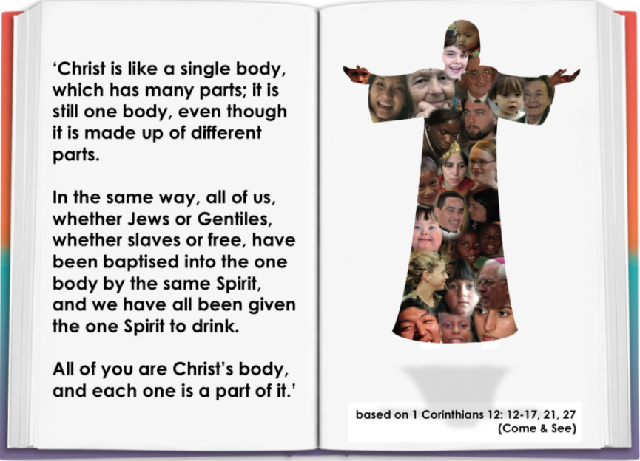

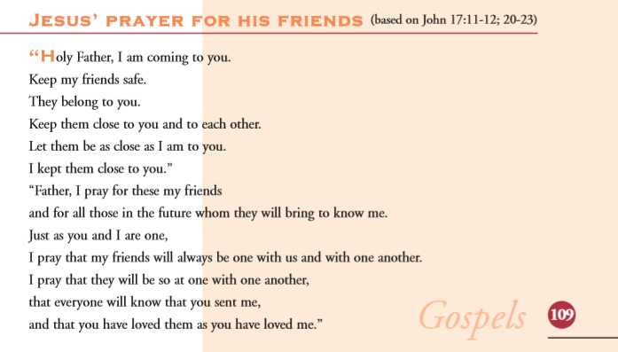

PHSE- Oak National Academy. Follow link Eat well, live well. Lesson 3 Time to Get Active!
https://classroom.thenational.academy/lessons/time-to-get-active-cth62c

Music – Oak National Academy. Follow link pulse and rhythm Lesson 3 Reading Simple Rhythm
https://classroom.thenational.academy/lessons/reading-simple-rhythms-c5h3ad

Computing this week is to understand systems. Follow the link below
https://classroom.thenational.academy/lessons/systems-cgvpad

Parents homework(!)
Please post your comments about last week’s narratives on our class stream.

Have a good week!
Best wishes
Mrs B

