Year B Spring 2 | Year B Spring 2
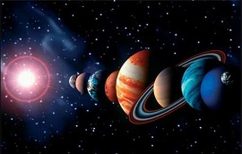  The Earth and Beyond | 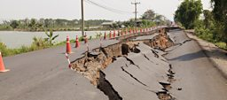  Natural Disasters
Enquiry Questions  What qualities do we need to be great explorers? | Enquiry Questions  What effect do Earthquakes have on communities?
Virtues  Confidence (Y2) Fortitude  Perseverance (Y3) Fortitude | Virtues  Friendliness (Y2) Justice  Thankfulness (Y3) Justice
Link with Catholic Social Teaching  Dignity of work; Rights and responsibilities; Families and Communities. | Link with Catholic Social Teaching  Family and community; Solidarity
UN Sustainable Development Goals  Goal 1 – No poverty  Goal 3 – Good health and well being  Goal 5 –Gender equality | UN Sustainable Development Goals  Goal 7: Affordable and clean energy  Goal 9: Industry, innovation and Infrastructure.  Goal 11: Sustainable cities and communities
Trips/visitors/events to enhance learning  Golden Hind - Brixham | Trips/visitors/events to enhance learning
Science  Forces and Magnets | Science  Light
History  What does it take to be a great explorer? | Geography  Why do some earthquakes cause more damage than others?
PSHCE  Rights and Responsibilities  Taking care of the Environment | PSCHE  Rights and responsibilities/Money
RE  Listening and Sharing; Giving all | RE  Promises; Visitors; Journeys
Music  Exploring Sounds – Memory and Movement | Music  Exploring Sounds – Memory and Movement
Art  3D | Art  Drawing
DT | DT  2D Shape into 3D product
Computing  Use logical reasoning to predict the behaviour of simple programmes | Computing  Use logical reasoning to predict the behaviour of simple programmes
French  On Fait la Fete – Celebrations | French  Portraits
PE  Dance | PE  Multi-skills – games

