Class 3 Home Learning Spring Term 1st half week 6
Hello Class 3. I hope you are all well and keeping safe. Thank you once again for joining me on the live lessons. This weeks English live lessons will take place daily on Google classroom at 9:30. It’s
always great to see you all. I look forward to reading your unicorn non chronological reports.
There will be a special celebration assembly at 9:30 on Friday so please bring work with you that you are proud of.
Please can you upload your work onto the class stream in the folders. Parents please e mail or call me if you need to chat. Many thanks for your continued support this half term.
Here is your home learning for this week…
- Daily reading 20 mins daily
- Rockstars 20 mins daily
- Remember to keep an ongoing log of your daily reading.
- Daily PE – Keep going with your Joe Wicks workout!
- Please can you upload your home learning reading diaries in the reading folder.
- Spellings Purple Mash Year 6 Spring 1 week 3 LCWSC
- Spellings Purple Mash Year 5 Spring 1 week 3 LCWSC
- Spellings Purple Mash Year 4 Autumn 1 week 1 LCWSC

Eng On-line live lessons. Our focus will be Myths of Dartmoor.
Maths focus
Y5 I have sent you a video link. Follow this link for your final week on fractions. There are also daily question sheets attached via email.
https://whiterosemaths.com/homelearning/year-5/spring-week-6-number-fractions/

Year 6 I have sent you a video link. Follow this link for algebra. There are also daily question sheets attached via email.
https://whiterosemaths.com/homelearning/year-6/spring-week-5-number-algebra/
Y6 Maths have a go challenge – https://nrich.maths.org/7216
Nrich Your Number Was ……..
Y4 I have sent you a video link. Please follow the video on your final week on fractions. There are also daily question sheets attached via email.
https://whiterosemaths.com/homelearning/year-4/spring-week-6-number-fractions/

For IXL fractions please see:
Y4 Fractions Y6 Y7
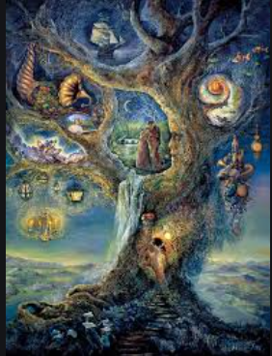
Y5 Fractions S17 S18
Y6 T 3 Variable expressions
Art Following on from our Unicorn focus, can you create an image in the style of the artist Josephine Wall?
Science – This week we will focus on levers and pulleys. Please follow the video link on Oak Academy
https://classroom.thenational.academy/lessons/what-impact-do-gears-levers-and-pulleys-have-on-forces-60w3cd
Here is a Bitesize video on pulleys and levers
https://www.bbc.co.uk/bitesize/clips/zrp6n39
Watch the videos as after half term we will attempt to make a homemade pulley! Start collecting your ideas.

Geography – Please follow Lesson 3
https://classroom.thenational.academy/lessons/what-landforms-do-rivers-create-part-1-70rp8r
You can do the quiz and make a note of any new learning.
RE To complete our focus on Local Church please write a prayer about Christian unity. Here is a scaffold.
Prayer
God, give us peace in our hearts,
Peace in our families,
Peace in our school,
Peace in our village (or town/city/area),
Peace in our country,
Peace in our world.
Amen.
French
Please follow this link to start speaking French!
https://classroom.thenational.academy/units/ou-habites-tu-cade
PHSE
Last week was Mental Health Awareness Week – we are creating a display for Class 3. Look through the power point and try the bunting activity.
Computing
Have a go at 2Logo on Purple Mash –there is an instructional video to watch on Purple Mash.
Have a good week and a well-deserved half term!

