Year 2 and 3 RE Focus – Pentecost Serving
This term our RE focus is Pentecost - Serving
The children’s Big Question is: What’s the use of energy?
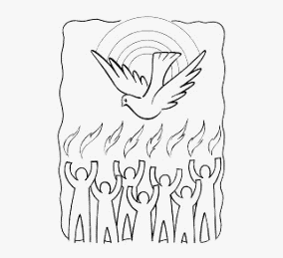
The children will be reflecting on this and asking: How can the energy of the wind be used for good? How do the gifts of the Holy Spirit help people to live Christian lives in serving others?
Together they will be exploring: How the power of fire and wind and how this energy can be used for good. They will retell and ask questions about the story of the Ascension and the coming of the Holy Spirit
They will be reading relevant scriptures: Matthew 28: 1-10, John 16: 5-7,1 Corinthians 12: 4-8, 11, Acts 1: 6-11, Acts 2: 1-18, 43, Isaiah 11: 2 and their prayer focus will be the Glorious Mysteries of the Rosary and prayer to the Holy Spirit. They will also be exploring the following themes which we encourage you to discuss with them at home:
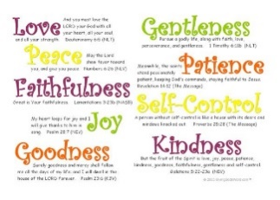 | Holy Spirit  The Holy Spirit is our helper, teacher, comforter, and our friend! We can see The Holy Spirit in the joy, the courage and the strength that it gives. The Holy Spirit inspires us with good ideas and its gifts helps us to carry them out.
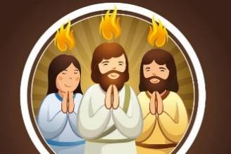 | Pentecost  Pentecost is celebrated 50 days after Easter and is when Christians remember the gift of the Holy Spirit. The Holy Spirit is the third part of the Trinity - Father, Son and Holy Spirit.
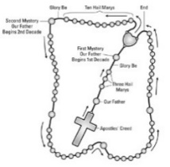 | Rosary: The word ‘Rosary’ means a crown of roses. The Rosary is a cycle of repeated prayers: The Lord's Prayer and the Hail Mary. While said, we think about the important events in the lives of Jesus and Mary.
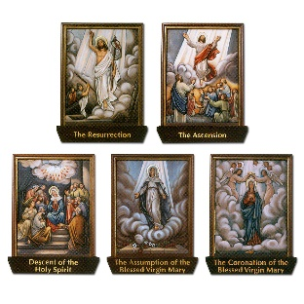 | Glorious Mysteries: As we pray the Rosary, and contemplate the Crucifixion of Jesus, we enter into prayer: ‘The Glorious Mysteries’. These are:  The Resurrection: Jesus rises from the dead.  The Ascension: Jesus ascends to heaven after telling his disciples that he will be with them in Spirit forever.  The Holy Spirit: comes as a wonderful gift from Jesus to teach our hearts and minds about God.

Key Vocabulary
fire, warmth, wind, energy, power, gifts, Holy Spirit, Rosary, Glorious Mysteries, Pentecost

