Year B Autumn 1 | Year B Autumn 2
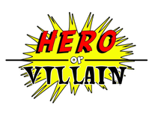  Heroes and Villains | 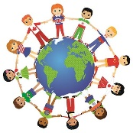  My Global Family
Enquiry Questions  Do people in history still affect our lives today?  Was Guy Fawkes a hero or villain? | Enquiry Questions  How can we care for creation?
Virtues  Friendliness (Y2) Justice  Perseverance (Y3) Fortitude | Virtues  Self-knowledge (Y2) Prudence  Meditation (Y3) Reflection
Link with Catholic Social Teaching  Family and community; Options for the poor and vulnerable; Dignity of the Human Person. | Link with Catholic Social Teaching  Family and community; Options for the poor and vulnerable, Stewardship.
UN Sustainable Development Goals  Goal 1 – No poverty  Goal 3 – Good health and well being  Goal 5 –Gender equality | UN Sustainable Development Goals  Goal 9: Industry, innovation and Infrastructure.  Goal 11: Sustainable cities and communities  Goal 12: Responsible Consumption and Production
Trips/visitors/events to enhance learning | Trips/visitors/events to enhance learning  Local Area walk to the river
Science  Animals including Humans | Science  Animal Including Humans
History  Who is the greatest history maker?  Key events in history (recognise differences between past and present in their own and other people’s lives). | Geography  How the geography of Kampong Ayer compares with the geography of where I live.
PSHCE  Healthy lifestyles  Growing and Changing | PSCHE  Keeping Safe  Healthy Lifestyles
RE  Homes; Judaism | RE  Promises; Visitors; Journeys
Music  Pitch – untuned instruments | Music  Pitch - composition
Art  Textiles | Art  Painting
DT | DT  Free-standing structures
Computing  Create and debug simple programmes | Computing  Create and debug simple programmes
French  Moi – All about me | French  Jeux et Chansons – Games and songs
PE  Multi-skills – Games | PE  Gymnastics

