Special Educational Needs (SEN) Information Report

St John the Baptist RC School



Approved by: | NJ | Date: Oct 25
Last reviewed on: | Oct 24
Next review due by: | Oct 26

Contents
Contents 2
1. What types of SEN does the school provide for? 3
2. Which staff will support my child, and what training have they had? 5
3. What should I do if I think my child has SEN? 6
4. How will the school know if my child needs SEN support? 7
5. How will the school measure my child’s progress? 7
6. How will I be involved in decisions made about my child’s education? 8
7. How will my child be involved in decisions made about their education? 8
8. How will the school adapt its teaching for my child? 9
9. How will the school evaluate whether the support in place is helping my child? 10
10. How will the school resources be secured for my child? 10
11. How will the school make sure my child is included in activities alongside pupils who don’t have SEN? 10
12. How does the school make sure the admissions process is fair for pupils with SEN or a disability? 11
13. How does the school support pupils with disabilities? 11
14. How will the school support my child’s mental health and emotional and social development? 11
15. What support will be available for my child as they transition between classes or settings or in preparing for adulthood? 12
16. What support is in place for looked-after and previously looked-after children with SEN? 13
17. What should I do if I have a complaint about my child’s SEN support? 13
18. What support is available for me and my family? 13
19. Glossary 14

Dear Parents and Carers,
The aim of this information report is to explain how we implement our SEND policy. In other words, we want to show you how special educational needs support works in our school.
If you want to know more about our arrangements for SEND, please read our SEND policy or make contact with the school and we will arrange for our SENDCo, Liz Hamilton to meet with you and talk to you.
You can find it on our website
At St John the Baptist RC School we aim to ensure that all children are fully included in the life of our school and able to engage in the rich, exciting and rewarding opportunities we offer. We work hard to adapt our provision to enable every child to take part both inside the classroom and in the wider school environment. The information in this report helps to highlight how we do this.
Note: If there are any terms we’ve used in this information report that you’re unsure of, you can look them up in the Glossary at the end of the report.
We look forward to working with you!

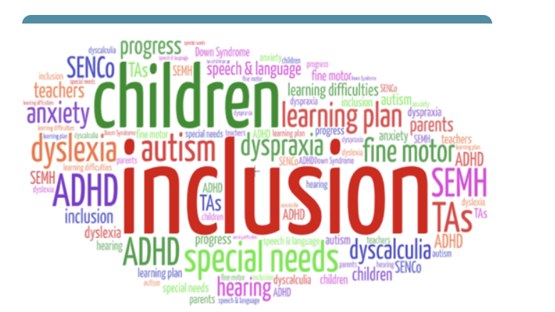

1. What types of SEN does the school provide for?
Our school provides for pupils with the following needs:

Area of need | Condition
Communication and interaction | Autism spectrum disorder (ASD)
Communication and interaction | Speech and language difficulties
Cognition and learning | Specific learning difficulties, including dyslexia, dyspraxia, dyscalculia
Cognition and learning | Moderate learning difficulties
Cognition and learning | Severe learning difficulties
Social, emotional and mental health | Attention deficit hyperactivity disorder (ADHD)
Social, emotional and mental health | Attention deficit disorder (ADD)
Sensory and/or physical | Hearing impairments
Sensory and/or physical | Visual impairment
Sensory and/or physical | Multi-sensory impairment
Sensory and/or physical | Physical impairment

2. Which staff will support my child, and what training have they had?
Our special educational needs co-ordinator, or SENDCO
Our SENDCO is Liz Hamilton.
They have 20 years experience in this role and has worked as headteacher of the school during this time. They are a qualified teacher and a Trauma Informed Practitioner (Level 5) and also has an Advanced Diploma on working with parents with Trauma Informed Approaches.
They are able to designate time each working day to this role.
Class Teachers
All of our teachers receive in-house SEN training, and are supported by the SENCO to meet the needs of pupils who have SEN.

Teaching Assistants (TAs)
We have a team of highly experienced teaching assistants who have worked at the school for many years and between them have a wealth of experience supporting children with a wide range of needs.
We have a trained Play therapist who works in school 1 day a week supporting social and emotional needs.
In the last academic year, TAs have been trained in ASD, PDA, Communication and Interaction, Precision teaching, Sensory circuits, Trauma Informed Approaches including supporting a wide range of mental health needs and PACE. .
External agencies and experts
Sometimes we need extra help to offer our pupils the support they need. Whenever necessary we will work with external support services to meet the needs of our pupils with SEN and to support their families. These include:
- Speech and language therapists
- Educational psychologists
- Occupational therapists
- GPs or paediatricians
- School nurses
- Child and adolescent mental health services (CAMHS)
- Education welfare officers
- Social services and other local authority (LA)-provided support services
- Voluntary sector organisations
- Play Therapist ( works in school 1 day a week)

3. What should I do if I think my child has SEN?
At St John the Baptist RC School we follow the Plymouth CAST SEND Pathway. This follows a graduated approach to SEND.
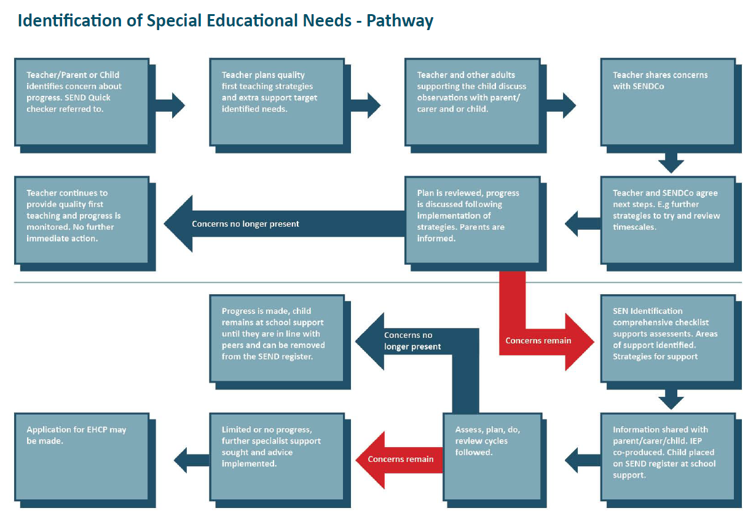
If you think your child might have SEN, the first person you should tell is your child’s teacher who is available and an appointment can be made through the school office.  They will pass the message on to our SENCO, Liz Hamilton who will be in touch to discuss your concerns.  You can also contact the SENCO directly through admin@st-johns-dartmouth.devon.sch.uk | We will meet with you to discuss your concerns and try to get a better understanding of what your child’s strengths and difficulties are.  Together we will decide what outcomes to seek for your child and agree on next steps.  We will make a note of what’s been discussed and add this to your child’s record. You will also be given a copy of this. | If we decide that your child needs SEN support, we will formally notify you in writing and your child will be added to the school’s SEND register.

4. How will the school know if my child needs SEN support?
All our class teachers are aware of SEN and are on the lookout for any pupils who aren’t making the expected level of progress in their schoolwork or socially.
If the teacher notices that a pupil is falling behind, they try to find out if the pupil has any gaps in their learning. If they can find a gap, they will support the pupil to fill it. This may be by slightly adapting the way things are being taught, providing some additional short term support , additional teaching or working with you to support your child with some additional practice at home. Pupils who don’t have SEN usually make progress quickly once the gap in their learning has been filled.
If the pupil is still struggling to make the expected progress, the teacher will talk to the SENCO, and will contact you to discuss the possibility that your child has SEN.
The SENCO will observe the pupil in the classroom and in the playground to see what their strengths and difficulties are. They will have discussions with your child’s teacher/s, to see if there have been any issues with, or changes in, their progress, attainment or behaviour. They will also compare your child's progress and development with their peers and available national data.

The SENCO will ask for your opinion and speak to your child to get their input as well. They may also, where appropriate, ask for the opinion of external experts such as a speech and language therapist, an educational psychologist, or a paediatrician.
Based on all of this information, the SENCO will decide whether your child needs SEN support. You will be told the outcome of the decision in writing.
If your child does need SEN support, their name will be added to the school’s SEND register, and the SENCO will work with you to create a SEN support plan for them.

5. How will the school measure my child’s progress?
We will follow the ‘graduated approach’ to meeting your child’s SEN needs.
The graduated approach is a 4-part cycle of assess, plan, do, review.
Assess
If your child is not making the expected level of progress, we will make an assessment to find out what strengths and difficulties your child has. We will ask for input from you and your child, as well as getting help from external professionals where necessary.
Review
We will assess how well the support we put in place helped the child to meet the outcomes we set. We will use our improved understanding of
your child’s needs to improve the support we offer.

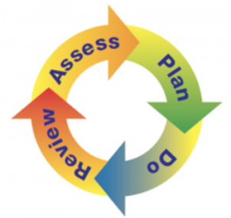

Do
We will put our plan into practice.
The class teacher, with the support of the SENCO, will be responsible for working with your child on a daily basis, and making sure the support we put in place is having the impact we intended.
Plan
In discussion with you and your child, we will decide what outcomes we are hoping to achieve. We will make a plan of the support we will offer your child to help them meet those outcomes. We will make a record of this and share it with you and all relevant school staff.

As a part of the planning stage of the graduated approach, we will set outcomes that we want to see your child achieve.
Whenever we run an intervention with your child, we will assess them before the intervention begins. This is known as a ‘baseline assessment’. We do this so we can see how much impact the intervention has on your child’s progress.
We will track your child’s progress towards the outcomes we set over time and improve our offer as we learn what your child responds to best.
This process will be continual. If the review shows a pupil has made progress, they may no longer need the additional provision made through SEN support. For others, the cycle will continue and the school's targets, strategies and provisions will be revisited and refined.

6. How will I be involved in decisions made about my child’s education?
We will provide annual reports on your child's progress.
Your child’s class/form teacher will meet you 3 times a year to:
- Set clear outcomes for your child’s progress
- Review progress towards those outcomes
- Discuss the support we will put in place to help your child make that progress
- Identify what we will do, what we will ask you to do, and what we will ask your child to do
The SENCO may also attend these meetings to provide extra support if this is requested or needed.
We know that you’re the expert when it comes to your child’s needs and aspirations. So we want to make sure you have a full understanding of how we’re trying to meet your child’s needs, so that you can provide insight into what you think would work best for your child.
We also want to hear from you as much as possible so that we can build a better picture of how the SEN support we are providing is impacting your child outside of school.
If your child’s needs or aspirations change at any time, please let us know right away so we can keep our provision as relevant as possible.
After any discussion we will make a record of any outcomes, actions and support that have been agreed. This record will be shared with all relevant staff, and you will be given a copy.
If you have concerns that arise between these meetings, please contact your child’s class teacher either through Dojo or the School Office.

7. How will my child be involved in decisions made about their education?
The level of involvement will depend on your child’s age and level of competence. We recognise that no 2 children are the same, so we will decide on a case-by-case basis, with your input.
We may seek your child’s views by asking them to:
- Attend meetings to discuss their progress and outcomes
- Prepare a presentation, written statement, video, drawing, etc.
- Discuss their views with a member of staff who can act as a representative during the meeting
- Complete a survey

8. How will the school adapt its teaching for my child?
Your child’s teacher is responsible and accountable for the progress and development of all the pupils in their class.
High-quality teaching is our first step in responding to your child’s needs. We will make sure that your child has access to a broad and balanced curriculum in every year they are at our school.
We will adapt how we teach to suit the way the pupil works best. There is no '1 size fits all’ approach to adapting the curriculum, we work on a case-by case basis to make sure the adaptations we make are meaningful to your child.
These adaptations include:

- Differentiating our curriculum to make sure all pupils are able to access it, for example, by grouping, 1-to-1 work, adapting the teaching style or content of the lesson, etc.
- Differentiating our teaching, for example, giving longer processing times, pre-teaching of key vocabulary, reading instructions aloud, etc.
- Adapting our resources and staffing
- Using recommended aids, such as laptops, coloured overlays, visual timetables, larger font, etc.
- Teaching assistants will support pupils on a 1-to-1 or small group basis at times.

- Teaching assistants will support pupils in small groups when
We may also provide the following interventions: Speech and Language, Language Link, Read Write Inc Phonics, Colourful Semantics, Nessy spelling, Mastering Number, Emotions Cards, Sand Play, Big Empathy Drawings, Social Stories, Toe by Toe, Precision Teaching, Sensory Circuits,

Area of need | Condition | How we support these pupils
Communication and interaction | Autism spectrum disorder (ASD) | Visual timetables  Social stories
Communication and interaction | Speech and language difficulties | Speech and language therapy  Langauge Link assessments  AAC tool  Makaton  Colourful Semantics  Writing slope  Nessy  Toe by Toe  Sensory circuits
Cognition and learning | Specific learning difficulties, including dyslexia, dyspraxia and dyscalculia
Cognition and learning | Moderate learning difficulties
Cognition and learning | Severe learning difficulties
Social, emotional and mental health | ADHD, ADD | Quiet workstation  Sensory learning breaks
Social, emotional and mental health | Adverse childhood experiences and/or mental health issues | Trauma Informed practitioner  Play therapist  Sand play  Emotions cards  PACE  Big Empathy Drawings
Sensory and/or physical | Hearing impairment | Specialist advice sought from specialist advisors  Makaton L2 trained member of staff.
Sensory and/or physical | Visual impairment | Limiting classroom displays
Sensory and/or physical | Multi-sensory impairment | Sensory circuits  Learning breaks  Advice from sensory reports followed/ work with external agencies.
Sensory and/or physical | Physical impairment | Follow specialst advice and personalise to needs of the child.

These interventions are part of our contribution to Devon s local offer.

9. How will the school evaluate whether the support in place is helping my child?
We will evaluate the effectiveness of provision for your child by:
- Reviewing their progress towards their goals each term
- Reviewing the impact of interventions after 6 weeks
- Monitoring by the SENCO
- Using provision maps to measure progress
- Holding an annual review (if they have an education, health and care (EHC) plan)
- Talk to pupils

10. How will the school resources be secured for my child?
It may be that your child’s needs mean we need to secure:
- Extra equipment or facilities
- More teaching assistant hours
- Further training for our staff
- External specialist expertise
If that’s the case, we will consult with external agencies to get recommendations on what will best help your child access their learning.
The school will cover up to £6,000 of any necessary costs. If funding is needed beyond this, we will seek it from our local authority. This will usually require applying to an Educational Health and Care Plan. This plan may include recommendations about the way in which any additional funding should be used. If the school needs to recruit additional staff, they will follow the Plymouth Cast recruitment policy. Approval for all posts must be sought from the Trust before the school can begin the recruitment process.

11. How will the school make sure my child is included in activities alongside pupils who don’t have SEN?
All of our extra-curricular activities and school visits are available to all our pupils, including our after-school clubs.
All pupils are encouraged to go on our school trips, including our residential trips.
All pupils are encouraged to take part in all school activities.
No pupil is ever excluded from taking part in these activities because of their SEN or disability and we will make whatever reasonable adjustments are needed to make sure they can be included.

12. How does the school make sure the admissions process is fair for pupils with SEN or a disability?
- Pupils whose EHC plan names the school will be admitted before any other places are allocated
- At St John the Baptist RC school the oversubscription criteria avoids unfairly disadvantaging prospective pupils with a disability or special educational needs

13. How does the school support pupils with disabilities?
- St John the Baptist RC School is fully inclusive and disabled pupils are treated less favourably than other pupils. The school is flat and on one floor so is fully accessible by a wheelchair.
- The school’s accessibility plan is available on request from the school office.
  - Increase the extent to which disabled pupils can participate in the curriculum
  - Improve the physical environment to enable disabled pupils to take better advantage of the education, benefits, facilities and services you provide
  - Improve the availability of accessible information to disabled pupils

14. How will the school support my child’s mental health, and emotional and social development?

All Schools within the Trust are working towards becoming Trauma Informed Schools and all adults have had training to help them recognise signs that children may be having difficulty socially, emotionally or mentally. Adults are trained in ways to support children and all children have trusted adults that they can reach out to at times of difficulty.
We provide support for pupils to progress in their emotional and social development in the following ways:
- Pupils with SEN are encouraged to be part of the school council
- We survey all pupils at least once a year to seek their views about how well they are settled in school and how well they are connected to the adults and their peers.This is called our School Bonding Questionnaire
- Pupils with SEN are also encouraged to be part in all clubs to promote teamwork/building friendships
- We provide extra pastoral support for listening to the views of pupils with SEN by use of PACE and Trauma Informed Approaches e.g. PACE
- There is a Play therapist who works 1 day a week supporting pupils with social and emotional needs. The level 5 TIS practitioner also works 1:1 with children and supports staff training.
- We have a ‘zero tolerance’ approach to bullying. We prevent bullying in the school by working closely with parents.

15. What support will be available for my child as they transition between classes or settings, or in preparing for adulthood?

Between years
To help pupils with SEN be prepared for a new school year we:
- Ask both the current teacher and the next year’s teacher to attend a final meeting of the year when the pupil’s SEN is discussed
- Schedule lessons with the incoming teacher towards the end of the summer term
- We are a very small school and staff get to know all pupils in the school right from the start of Foundation.
Between schools
When your child is moving on from our school, we will ask you and your child what information you want us to share with the new setting.
Between phases
The SENCO of the secondary school will come into our school for a meeting with our SENCO/ Class teachers. They will discuss the needs of all the children who are receiving SEN support.
Pupils will be prepared for the transition by:
- Practising with a secondary school timetable
- Learning how to get organised independently
- Plugging any gaps in knowledge
Between phases (for secondary schools)
The SENCO of the primary school meets with our SENCO to discuss the needs of the incoming pupils near the end of the summer term.
We arrange meetings with the parents/carers of incoming pupils to discuss how we can best welcome their child into our community.
We set up new pupils with a buddy from the year above to help them get settled in and make friends.
Moving to adulthood (for secondary schools)
We provide all our pupils with appropriate advice on paths into work or further education.
We work with the pupil to help them achieve their ambitions, which can include goals in higher education, employment, independent living and participation in society.

16. What support is in place for looked-after and previously looked-after children with SEN?
Liz Hamilton, our SENCO, makes sure that all teachers understand how a looked-after or previously looked-after pupil’s circumstances and their SEN might interact, and what the implications are for teaching and learning.
Children who are looked-after or previously looked-after will be supported much in the same way as any other child who has SEN. However, looked-after pupils will also have a personal education plan (PEP). We will make sure that the PEP and any SEN support plans or EHC plans are consistent and complement one another.

17. What should I do if I have a concern about my child’s SEN support?
If you have concerns about the progress your child is making or the support they are receiving you should speak to the class teacher in the first instance. They may suggest that you have a meeting with the SENDCo to discuss your concerns and work together to agree how to address these. If you are still concerned you should follow the school complaints procedure. You can find a copy of that from the School Offce.

18. What support is available for me and my family?
If you have questions about SEN, or are struggling to cope, please get in touch to let us know. We want to support you, your child and your family.
To see what support is available to you locally, have a look at Devon’s Local offer which is available on the Devon Website.
https://www.devon.gov.uk/children-families-education/send-local-offer.
Our local special educational needs and disabilities information, advice and support (SENDIAS) services are:
https://www.kids.org.uk/sendiass-home/
Local charities that offer information and support to families of children with SEN are:
National charities that offer information and support to families of children with SEN are:
- IPSEA
- SEND family support
- NSPCC
- Family Action
- Special Needs Jungle

19. Glossary
- Access arrangements – special arrangements to allow pupils with SEN to access assessments or exams
- Annual review – an annual meeting to review the provision in a pupil’s EHC plan
- Area of need – the 4 areas of need describe different types of needs a pupil with SEN can have. The 4 areas are communication and interaction; cognition and learning; physical and/or sensory; and social, emotional and mental health needs
- CAMHS – child and adolescent mental health services
- Differentiation – when teachers adapt how they teach in response to a pupil’s needs
- EHCP needs assessment – the needs assessment is the first step on the way to securing an EHC plan. The local authority will do an assessment to decide whether a child needs an EHC plan
- EHC plan – an education, health and care (EHC) plan is a legally-binding document that sets out a child’s needs and the provision that will be put in place to meet their needs
- First-tier tribunal / SEND tribunal – a court where you can appeal against the local authority’s decisions about EHC needs assessments or plans and against discrimination by a school or local authority due to SEN
- Graduated approach – an approach to providing SEN support in which the school provides support in successive cycles of assessing the pupil’s needs, planning the provision, implementing the plan, and reviewing the impact of the action on the pupil
- Intervention – a short-term, targeted approach to teaching a pupil with a specific outcome in mind
- Local offer – information provided by the local authority that explains what services and support are on offer for pupils with SEN in the local area
- Outcome – target for improvement for pupils with SEN. These targets don't necessarily have to be related to academic attainment
- Reasonable adjustments – changes that the school must make to remove or reduce any disadvantages caused by a child’s disability
- SENCO – the special educational needs co-ordinator
- SEN – special educational needs
- SEND – special educational needs and disabilities
- SEND Code of Practice – the statutory guidance that schools must follow to support children with SEND
- SEN information report – a report that schools must publish on their website, that explains how the school supports pupils with SEN
- SEN support – special educational provision that meets the needs of pupils with SEN
- Transition – when a pupil moves between years, phases, schools or institutions or life stages

