**Religious Education at St Johns**

At St. John the Baptist Catholic Primary School, we are excited about following the new Religious Education Directory and its program "To Know You More Clearly".

Throughout 2025-26 this will be rolled out across EYFS, KS1 and KS2. It is an innovative and enriching new Religious Education program that seeks to deepen the spiritual journey of our pupils by fostering a profound understanding of Catholic teachings and values.

This program goes beyond the traditional curriculum, encouraging pupils to explore their faith through a lens of curiosity and introspection. Through engaging lessons, thoughtful reflections, and interactive activities, "To Know You More Clearly" creates a dynamic learning environment that encourages students to connect with their spirituality on a personal level.

This program not only imparts knowledge but also cultivates a genuine and enduring relationship with God, contributing to the overall spiritual development of our pupils.

Scripture is the foundation of each Branch and will develop knowledge, understanding, skills, compassion and awe and wonder across the curriculum.

The Ways of Knowing:

The ways of knowing describe the skills that pupils develop as they progress though the religious education curriculum. These are:

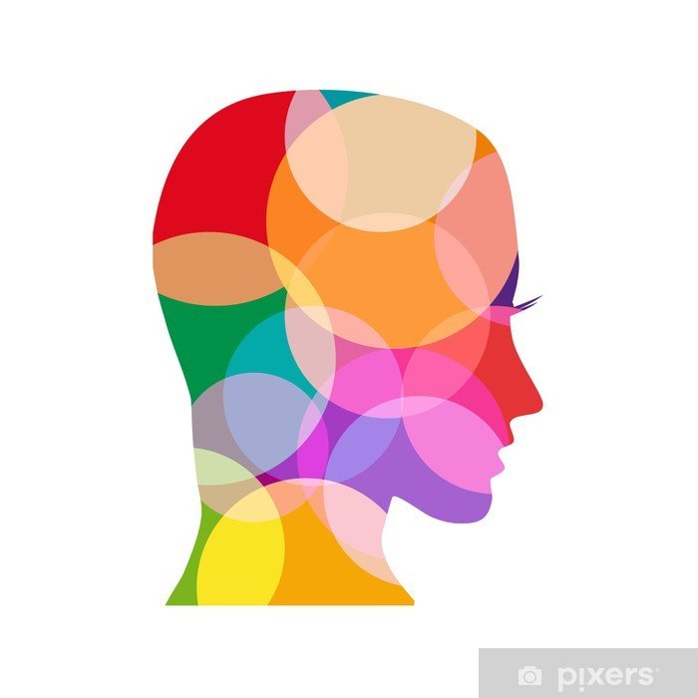

Understand:

In this way of knowing the aim is to help our pupils understand deeply the meaning of sacred texts, religious beliefs, sacred rites, and the lives of individuals and communities who are shaped by these texts, beliefs and rites.



Discern:

In this was of knowing the aim is to help our pupils to be able to judge wisely in response to different interpretations of the meaning, significance and implications of texts, beliefs, rites, and ways of life so that they can arrive at justified conclusions about what is true, what is good and what is beautiful.



Respond:

In this way of knowing, the aim is to help our pupils reflect personally and with integrity on what they have learnt and consider the implications for action these may have their own lives and the world in which they live.

Knowledge Lenses:

The knowledge lenses indicate what should be known by the end if each age phase. They are referred to as lenses since they are what we are looking at.

These are:



Hear:

The first knowledge lens is called ‘Hear’ and discusses the human capacity for God, Divine Revelation, and its transmission, Sacred Scripture, and the human response to God’s invitation. It is called ‘hear’ because it focuses on the Word of God which we hear.

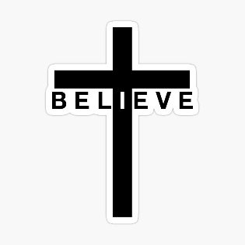

Believe:

The second knowledge lens is called ‘Believe’ and deals with the contents of the Creed. It is called ‘believe’ because it focuses on the content of the Church’s own profession of faith. In this lens we look at those doctrines that constitute our faith: trinity, incarnation, the Holy Spirit, the communion of saints, the role of the Blessed Virgin Mary.



Celebrate:

The third knowledge lens is called ‘Celebrate’ and is an exemplification of the Catechism that deals with liturgy and prayer. It is called ‘celebrate’ because it deals with the liturgy in which the Church celebrates the Paschal mystery of Christ. In this lens we look at prayer, liturgy, and sacrament, sacraments of initiation, the Eucharist, sacraments of healing, sacraments at the service of communion, and other liturgies and sacramentals.



Live:

The fourth knowledge lens is called ‘Live’ and is an exemplification of Catholic Social Teaching and deals with the ways in which the disciples of Christ are called to be in the world. It is called ‘live’ because it focuses on the impact of faith on how Christians live. In this lens we look at the dignity of the human person; freedom, conscience, and virtue; law, grace, and sin.



Dialogue:

The fifth knowledge lens is called ‘Dialogue’ and is an exemplification of the Church’s teaching on the relationship between Catholicism and other Christian traditions along with Catholicism and other religions and worldviews. It is called ‘Dialogue’ as this is the only authentic way of living faithfully in a world that accepts difference.



Encounter:

The sixth knowledge lens is called ‘Encounter’ and is when children engage in a discrete study of other faiths, religions and worldviews. It focusses is on the importance of loving out neighbours and respecting other cultures and learning how to live peacefully with difference.