St John the Baptist RC School
Oracy Policy

Date: Spring 23

Review: Spring 26



Contents Page

Intent Page 3

Teaching and Learning Page 4

EYFS Provision Page 5

Assessment Page 6

Teaching and Learning Page 7

Oracy Toolkit Page 8

Oracy across the Curriculum Page 9

Learning Environments Page 12

Inclusion Page 13

At St John the Baptist RC School, Oracy plays a key role in teaching and learning. The children develop the confidence and skills to listen and talk effectively by valuing different views and engaging in meaningful conversations. They communicate with others positively in all forms and articulate reasoned ideas.

In our school’s community, our aim is to promote all forms of communication and use all the available opportunities to encourage children to interact and learn through talk. Oracy is embedded across the curriculum and used to unlock new learning and challenge thinking.

Oracy is described as learning through talk whilst learning to talk and we understand how this can support the learning of all pupils and provide them with the opportunity to articulate their ideas and learn from each other as they explore new topics. We aim to provide pupils with the skills required to become confident speakers, using strongly embedded strategies aimed to support them beyond their school life.

The National Curriculum for English reflects the importance of spoken language in pupils’ development. Oracy is embedded throughout our broad and balanced curriculum and new strategies are explicitly taught to support learning. Questions are carefully planned to ensure that that all children can fully participate and there is a shared understanding that everyone’s opinion should be valued.

Some of the activities we use to help develop spoken language are:
- Partner Talk
- Group Discussion
- Debate
- Role Play
- Drama
- Presentation
- Collaborative work and problem solving

Teaching and Learning – The National Curriculum

Spoken Language – Years 1-6
Pupils should be taught to:

- Listen and respond appropriately to adults and their peers
- Ask relevant questions to extend their understanding and knowledge
- Use relevant strategies to build vocabulary
- Articulate and justify answers, arguments and opinions
- Give well-structured descriptions, explanations and narratives for different purposes, including for expressing feeling
- Maintain attention and participate actively in collaborative conversations, staying on topic and initiating and responding to comments
- Use spoken language to develop understanding through speculating, hypothesising, imagining and exploring ideas
- Speak audibly and fluently with an increasing command of Standard English
- Participate in discussions, presentations, performances, role play/improvisations and debates
- Gain, maintain and monitor the interest of the listener(s)
- Consider and evaluate different viewpoints, attending to and building on the contributions of others
- Select and use appropriate registers for effective communication

Notes and guidance (non-statutory)

These statements apply to all years. The content should be taught at a level appropriate to the age of the pupils. Pupils should build on the oral language skills that have been taught in preceding years.

Pupils should be taught to develop their competence in spoken language and listening to enhance the effectiveness of their communication across a range of contexts and to a range of audiences. They should therefore have opportunities to work in groups of different sizes – in pairs, small groups, large groups and as a whole class. Pupils should understand how to take turns and when and how to participate constructively in conversations and debates.

To support this, we will use the following tools:

- Discussion Guidelines
- Protocols (linked to turn-taking)
- Sentence stems and scaffolds

EYFS

Our EYFS curriculum is communication rich and carefully designed to deliver a broad and balanced array of topics, which ensure coverage and progression for all. It provides pupils with creative, memorable experiences in addition to diverse and rich opportunities, which build children’s aspirations demonstrating possibilities for their future lives.

Our school is using the EYFS Framework and all of our work evolves around the children’s ability to communicate and understand the wider world. We believe that in order to achieve in all areas of the curriculum, the pupils must meet their communication and language goals first.

The framework is divided into the following key areas:

- Communication and Language
- Personal, Social and Emotional Development
- Physical Development
- Literacy
- Mathematics
- Understanding the World
- Expressive Arts and Design

Pupils should be able to:

- Gaze at faces, copying facial expressions and movement. Make eye contact for longer periods.
- Watch someone’s face as they talk.
- Recognise and be calmed by a familiar and friendly voice.
- Listen and respond to a simple instruction.
- Use gestures like waving and pointing to communicate.
- Copy your gestures and words.
- Use intonation, pitch and changing volume when ‘talking’.
- Understand simple words in context.
- Listen to other people’s talk with interest, but can easily be distracted by other things.
- Start to develop conversation, often jumping from topic to topic.
- Start to say how they are feeling, using words as well as actions.
- Understand how to listen carefully and why listening is important.
- Learn new vocabulary.
- Use new vocabulary through the day.
- Articulate their thoughts and ideas in well-formed sentences.
- Describe events in some detail.
- Develop social phrases.
- Use new vocabulary in different contexts.

Teaching and Learning – St John the Baptist RC Oracy Framework

Pupils are taught Oracy skills across the curriculum. During these sessions, the children are taught about discussion techniques, vocabulary and listening skills. They explore the use of exploratory talk and presentational talk and teachers understand how to use these appropriately based on where they are within a sequence of learning.

We use the oracy framework developed by Voice 21, which breaks Oracy into four strands:

- Physical
- Linguistic
- Cognitive
- Social and Emotional

Oracy Toolkit
To support our teaching of oracy, we have developed our own resources as well as adapted existing materials.

Discussion Guidelines

These are a set of guidelines for partner and group discussions that help maintain an effective and respectful environment for talk. Each class has a set of guidelines.

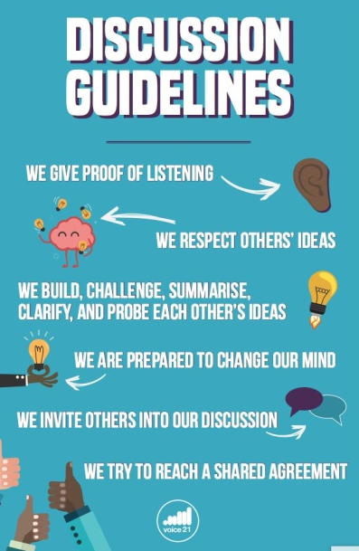

Talking Roles

We believe that it is very important for children to understand their role in a discussion and how to use vocabulary to communicate this effectively.

Talk Protocols
Talk protocols allow children to self-govern talk

Talk Detectives
Talk detective enable children to identify different Oracy skills used during a discussion.

Vocabulary Bullseye
This activity is based on teaching new vocabulary and it can also be used to develop peer feedback on writing.

Groupings
Groupings enable children to explore different types of talk and communicate for different purposes.

Presentational Oracy
Presentational skills are taught within lessons where children have the opportunity to share their work and ideas through performance poetry, assemblies, school productions and speech. We understand the different staring points of all pupils and adapt accordingly to suit their needs and ensure that their voices are valued, heard and nurtured.
During presentation, the children are encouraged to consider their pitch, tone, pace, gestures, pace, body language and projection.

Oracy across the curriculum
Whilst new skills are taught explicitly when first introduced, they become embedded in our curriculum as the children develop their fluency and confidence. We carefully plan for opportunities to talk and teachers are able to use their experience and knowledge to cultivate a talk-rich environment in their classroom.

Oracy in English
As a school, we are committed to raising and maintaining high standards for literacy. We support our pupils by providing them with a range of skills to help them to:

- Develop a rich vocabulary
- Participate in reasoned discussions
- Articulate and justify their answers
- Participate in role plays, presentations, discussions and debates
- Speak with appropriate volume and pitch with an increasing command of Standard English
- Give well-structured descriptions, explanations and narratives for different purposes
- Learn to use their language to persuade

We achieve this in the following way:

- Drama is used to immerse the pupils into different topics
- Vocabulary activities
- Presentation tasks
- Group discussions
- Partner talk

Oracy in Maths
Oracy is strongly embedded during Maths lessons to support the teaching of mathematical vocabulary, new concepts, support children in proving or justifying their answers to address misconceptions.

Oracy has a particularly important role in reasoning lessons, which focus on the children using their vocabulary to communicate their understanding of mathematics accurately. Children work collaboratively to solve problems and use sentence stems to support discussion.

Oracy in Science
In Science, children use their Oracy skills to:

- Ask relevant questions about scientific enquiries
- Communicate their findings in different ways
- Develop hypothesises collaboratively
- Use scientific vocabulary
- Talk about their findings to explain the steps taken

Learning environment
Our classroom displays are vibrant and monitored regularly by subject leaders to ensure their effectiveness in supporting all groups of learners. Oracy resources are clearly displayed and easy to access by the children and have been created to facilitate learning and discussions.

Inclusion
We have a strong understanding of the different starting points of our pupils and we value all forms of communication to ensure that everyone feels heard, included, valued and supported.
Our speech and language therapist works alongside our SENDCO and is able to make recommendations to support pupils with special educational needs and resources are carefully tailored to provide scaffolds for talk and communication.

Speech and language targets are carefully set for pupils who need support and these are developed with expert advice for maximum impact on the children’s learning and development.

Appendix 1 – Talking Roles

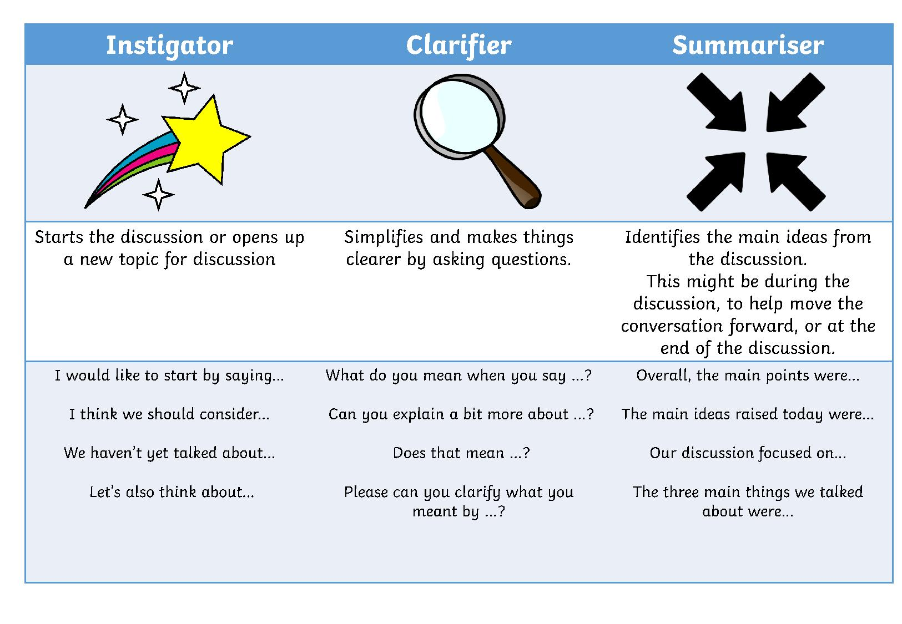
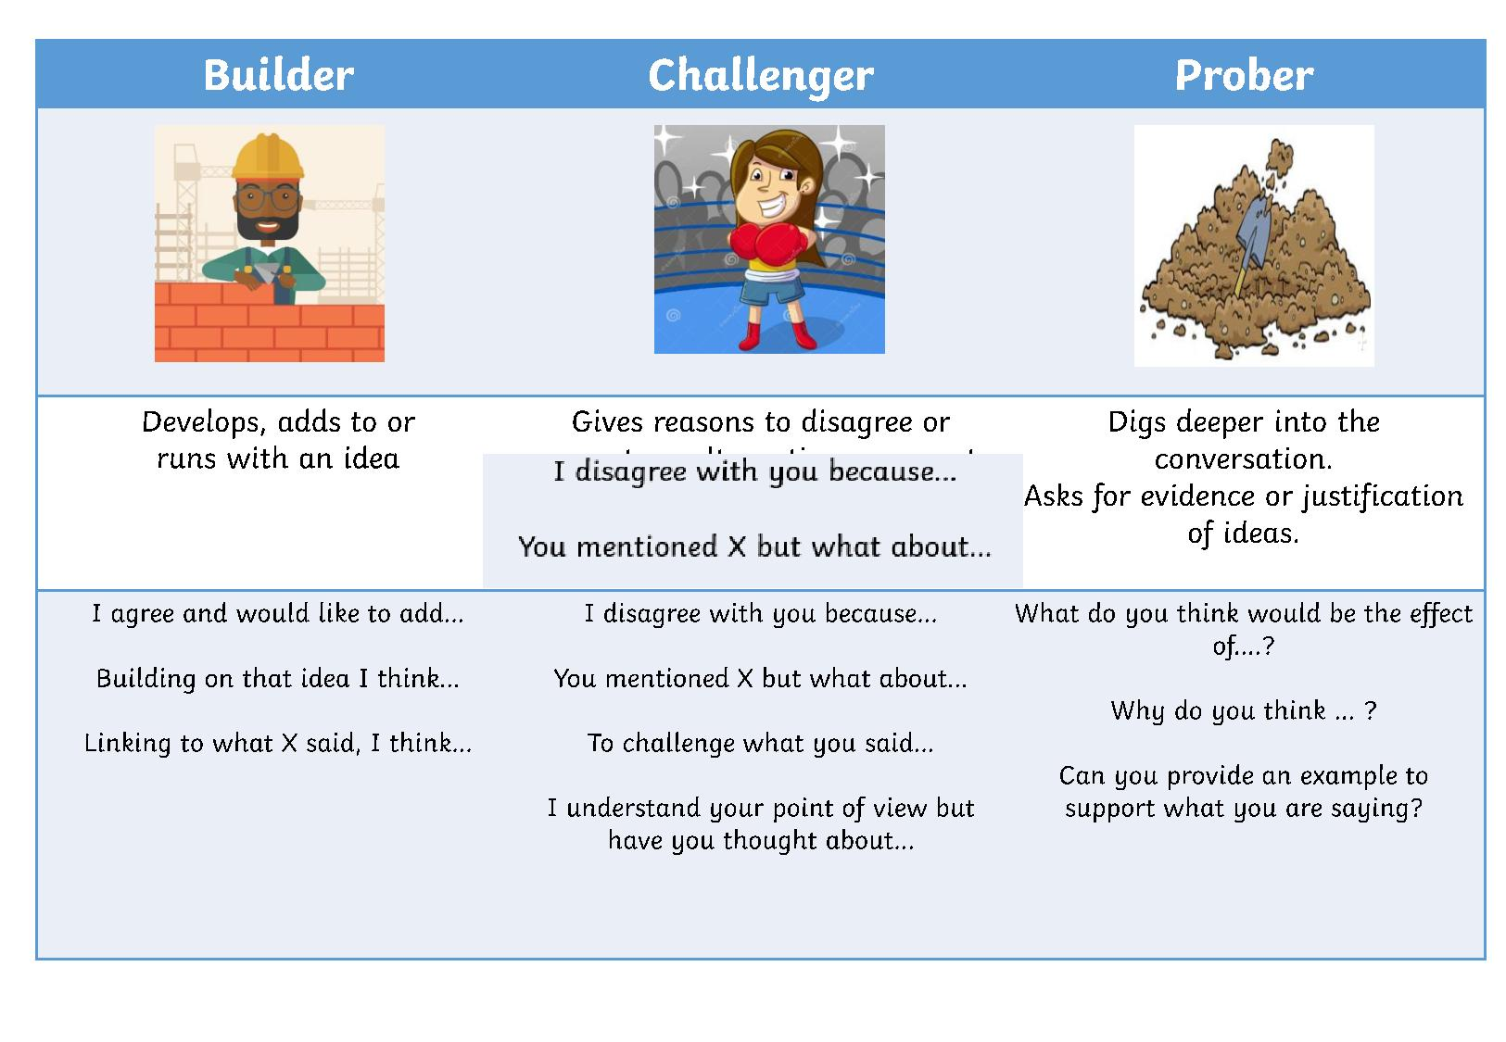
EYFS Sentence stems
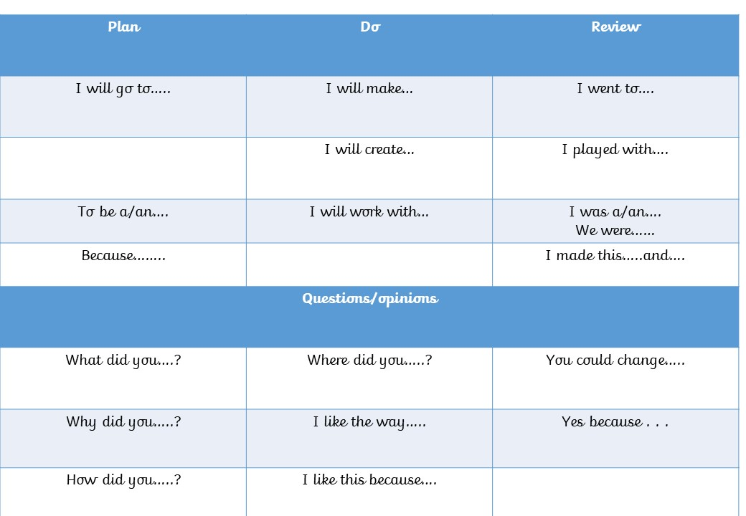
Key Stage 1
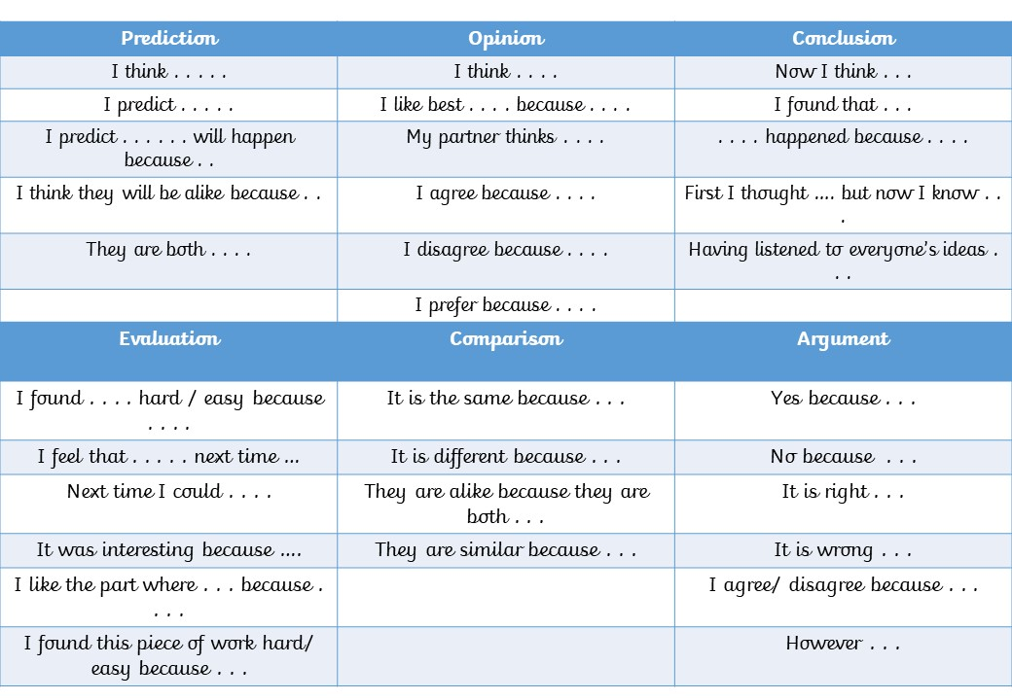
Key Stage 2 sentence stems
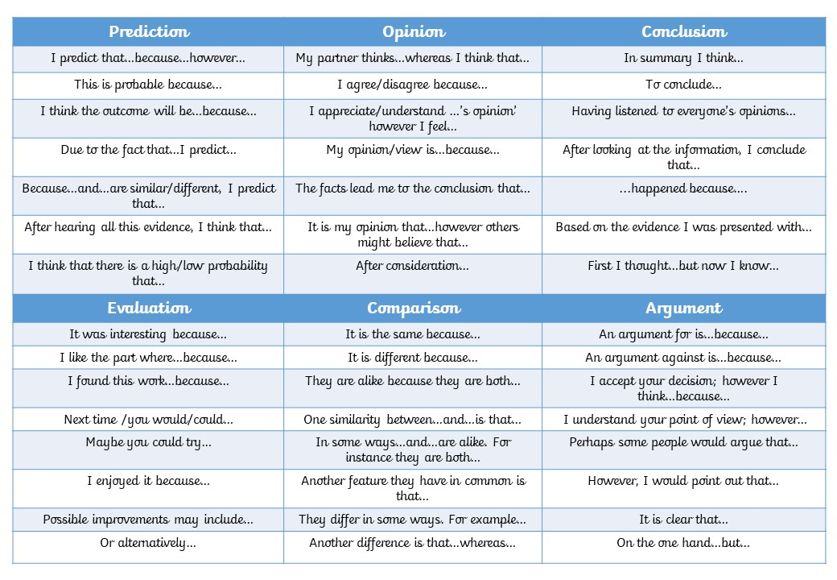
Appendix 2
Additional resources
