St John the Baptist RC School

 | Feedback Policy
Approved Autumn20 | Review Autumn 21

BACKGROUND INFORMATION
St John the Baptist is a small Catholic Primary School of approximately 80 pupils in the parish of Dartmouth. We are also part of Plymouth Catholic Anglican Schools Trust (CAST) a Multi- chain Academy Trust compromising 35 Catholic and Anglican Primary and Secondary schools spanning Devon, Dorset and Cornwall. In each year there are a number of children identified with Special Educational Needs. There is a wide social mix and very varied family backgrounds including single parent and children from a range of cultural and ethnic backgrounds. St Johns cover an urban residential area and also has children who travel in from local outlying villages. The school has an active Parent Teacher Association.
At St Johns, we recognise the importance of feedback as an integral part of the teaching and learning cycle, and aim to maximise the effectiveness of its use in practice. We are mindful also of the research surrounding effective feedback and the workload implications of written marking, as well as research from cognitive science on how fragile new learning can be. Now more than ever, teachers will be trying to give feedback in a way that maintains a student’s fragile self-esteem. Comfory feedback saying, ‘you did your best’ is to be avoided. The most effective feedback focuses on the next steps and helps pupils with strategies on how to do this.
Our policy is underpinned by the evidence of best practice from the Education Endowment Foundation and other expert organisations. The Education Endowment Foundation research shows that effective feedback should:

• Redirect or refocus either the teacher’s or the learner’s actions to achieve a goal
• Be specific, accurate and clear
• Encourage and support further effort
• Be given sparingly so that it is meaningful
• Put the onus on students to correct their own mistakes, rather than providing correct answers for them
• Alert the teacher to misconceptions, so that the teacher can address these in subsequent lessons.
The Department for Education’s research into teacher workload has highlighted written marking as a key contributing factor to workload. As such we have investigated alternatives to written marking which can provide effective feedback in line with the EEF’s recommendations, and those of the DfE’s expert group which emphasises that marking should be: Meaningful, manageable and motivating. We have also taken note of the advice provided by the NCETM (National Centre for Excellence in Teaching Mathematics) that the most important activity for teachers is the teaching itself, supported by the design and preparation of lessons.
Effective feedback
• The sole focus of feedback should be to further children’s learning;
• Feedback should not be used to provide additional evidence for external verification
• Feedback should empower children to take responsibility for improving their own work; it should not take away from this responsibility by adults doing the hard thinking work for the pupil.
• Written comments should only be used as a last resort for the very few children who otherwise are unable to locate their own errors, even after guided modelling by the teacher.
Children should receive feedback either within the lesson itself or it in the next appropriate lesson. The ‘next step’ is usually the next lesson.
• Feedback is a part of the school’s wider assessment processes which aim to provide an appropriate level of challenge to pupils in lessons, allowing them to make good progress.
• New learning is fragile and usually forgotten unless explicit steps are taken over time to revisit and refresh learning. Teachers should be wary of assuming that children have securely learnt material based on evidence drawn close to the point of teaching it. Therefore, teachers will need to get feedback at some distance from the original teaching input when assessing if learning is now secure.
Within these principles, our aim is to make use of the good practice approaches outlined by the EEF toolkit to ensure that children are provided with timely and purposeful feedback that furthers their learning, and that teachers are able to gather feedback and assessments that enable to adjust their teaching both within and across a sequence of lessons.
Feedback and marking in practice
It is vital that teachers evaluate the work that children undertake in lessons, and use information obtained from this to allow them to adjust their teaching. Feedback occurs at one of four common stages in the learning process:
1. Immediate feedback – at the point of teaching
2. Summary feedback - at the end of a lesson/task
3. Next lesson feedforward – further teaching enabling the children to identify and improve for themselves areas for development identified by the teacher upon review of work after a previous lesson had finished
4. Summative feedback – tasks planned to give teachers definitive feedback about whether a child has securely mastered the material under study
These practices can be seen in the following practice
Immediate Feedback
Includes teacher gathering feedback from teaching within the course of the lesson, including mini-whiteboards, bookwork, etc.
• Takes place in lessons with individuals or small groups
• Often given verbally to pupils for immediate action
• May involve use of a teaching assistant to provide support of further challenge
• May re-direct the focus of teaching or the task
Summary
• Takes place at the end of a lesson of activity
• Often involves whole groups or classes
• Provides an opportunity for evaluation of learning in the lesson
• May take form of self or peer- assessment against an agreed set of criteria
• May take the form of a quiz, test or score on a game
• In some cases, may guide a teacher’s further use of review feedback, focusing on areas of need
• Lesson observations/learning walks
• Some evidence of self – and peer-assessment
• Quiz and test results may be recorded in books or logged separately by the teacher
Feedforward:
• For writing in particular, often a large part of the next lesson will be spent giving feedback to the class about strengths and areas for development and giving time for development areas to be worked on and improved through proof reading and editing their work.
• Do now’s are analysed daily and errors and misconceptions addressed in subsequent lessons, in particular in maths conferencing.
Summative
• ‘Check it’ activities
• End of unit or term tests or quizzes
• Check it activities in books
• Quiz and test results
strategical minimal marking
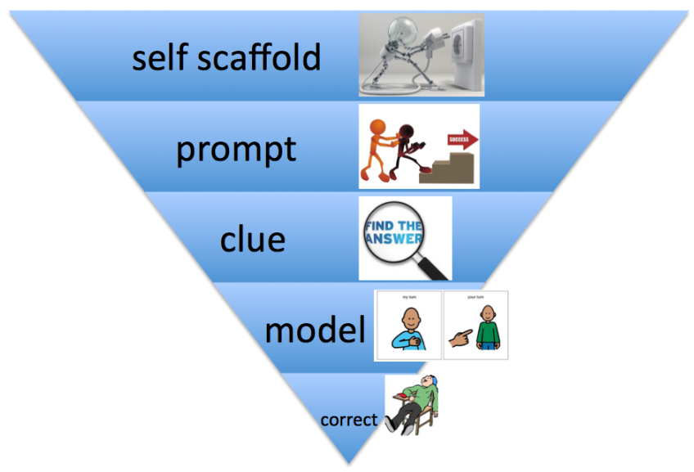
The above approach is taken from the MITA.Assume children can work independently
Let them do the work- not you
Gradually increase support WHEN IT IS NEEDED. Returning to the triangle reminds us that some pupils will need a gentle prompt to narrow down their focus when hunting for mistakes. So if it isn’t enough for some pupils, we can provide scaffolding through a quick comment alerting them of errors. Or even a simple pointer; ‘description’, ‘ambiguous pronouns’ or ‘figurative language’.
Others might need even more support. For example, the teacher might need to draw a yellow box around a section of text to narrow down the search area for the pupil, alongside the comment that there are speech marks missing or tenses jumped or the same sentence structure over-used.
Where mistakes are deeply entrenched, the teacher may need to do some direct work modelling how to overcome these. For example, to clear up the confusion with apostrophe use.
However, with all of this, it is in addition to (and not instead of) the teacher modelling editing for pupils before the independent section of the lesson.

Appendix 1
Guidance with writing
Proof reading and editing in writing lessons
Most writing lessons will be followed up with an editing lesson where children receive whole class feedback about strengths and areas for development and direct teaching about to help them identify and address their own weaknesses.
Teachers will have looked at pupils’ work soon after the previous lesson and identified strengths and weaknesses, looking at both the technical accuracy of the writing; spelling errors, punctuation omissions, and other transcription mishaps as well as things to do with the sophistication of the writing; the actual content. Where individual children have done particularly well or badly at something, s/he will make a note and use these in the lesson as a teaching point.
The editing lesson will be divided into two sections
proofreading
-Changing punctuation, spelling, handwriting and grammar mistakes.
editing
Improving their work to improve the composition.
The proofreading section will usually be short: about 10 minutes or so, whereas the editing element may take the rest of the lesson.
The teacher will share extracts from pupils’ work, using either a visualiser or by typing out a couple of lines and displaying them on the interactive whiteboard, at first showing good examples of work. For example, within the proof reading section, the teacher might showcase someone whose letter heights have the ascenders and descenders just right, then asking pupils to look at their work and rewrite one sentence from it, really making sure they are paying attention to letter heights. Then s/he might share a section of text with poor punctuation (usually anonymously) and reteach the class the various punctuation rules. They might then point out some spelling errors that several children are making, and remind children of the correct spelling and how to remember it. Children will then have a short period of time to proof read their work, checking for similar errors and putting them right. Children sit in mixed ability pairs and support each other in the identification and correction of mistakes.
Within the editing section of the lesson. For example, the teacher might show a different couple of pieces of work where children have described a character very well, pointing out what it is that has made the description so vivid. The teacher might then share a less good example which might be from an anonymous or fictional piece. The children would then suggest together how this might be improved. Then in their pairs they read together each other’s work, and suggest improvements, alterations and refinements which the author of the piece then adds – in green pen to help the teacher see what changes the child has made.
Intervening when children find editing hard
A few children will need more support than this in order to be successful at improving their own work. Younger children in KS1 in particular may need more support as they learn to become more independent, although many young children are quite able to edit and proof read independently after teacher modelling.
As with all intervention, teachers should always seek to use the minimal level possible, only escalating to the next level if the child still needs further support. Some children may need a gentle prompt to narrow down their focus when looking for mistakes, for example a written comment alerting them that there are some missing full stops, without telling them how many or where. Or a simple pointer – ‘description’ perhaps or ‘ambiguous pronouns’ or ‘figurative language’ or ‘and then’ crossed out. This would be in addition to, and not instead of, the teacher modelling editing for these before the independent section of the lesson. Others might need even more support and need to be provided with clues to help them. For example, the teacher might need to draw a yellow box around a section of text to narrow down the search area for the pupil, alongside the comment that there are speech marks missing or tenses jumped or the same sentence structure over-used. Or they might need to write a comment at the end saying there are 8 run-on sentences or 5 instances of non-standard English. In KS1 and for some Reception children, premade stampers are available to prompt children to look for certain mistakes. The ‘Crimes Against Writing’ prompt sheets (see appendix) should be used with KS2 classes until these basic skills are securely in place for most of the class. Certain individuals may need to carry on referring to these longer until the checklist is thoroughly internalised.
Where mistakes are deeply entrenched, or the children are very young and lack confidence, the teacher may need to do some direct work modelling how to overcome these: for example, to clear up the confusion with apostrophe use. The teacher might set a group of children an editing challenge based not on their own work but on a fictional piece of work with only one, recurrent error. An adult might then support the group in identifying where apostrophes do and do not belong. They might do this instead of editing their own work or as a prelude to it, depending upon their learning needs. But what the teacher is not doing is using a marking code that does all the error identification for the pupil as this takes away any responsibility from the pupil at thinking hard about how to improve. A highlighter pen can be used to highlight a section of work for improvement.

Appendix 2 – Guidance with maths

Marking policy approaches for maths

1. Pupils self-check their maths work
With our new system, Maths teachers now have answers to problems available. This means that, after four or five calculations, pupils can check their answers themselves. That way, if they have a misconception or misunderstand something they can alert the teacher immediately.
This avoids the situation where a child has diligently worked through reams of sums, as the class teacher works with a group, but has done entirely the wrong thing. This is worse still if it happens with a whole group.
Self-checking means that mistakes are realised ten minutes into the lesson, rather than at the end. It’s so much better for the pupils.
This approach also has the benefit of improving pupils’ confidence. We usually produce work at three levels of challenge. Pupils choose which level of challenge to start at and, naturally, less confident (but able) children usually start at the easiest level.
However, the new approach lets these pupils see when they get the first few calculations correct. Inevitably this helps them feel more confident and more willing to move on to the next level.
It also helps improve peer marking. For example, when more confident pupils finish their work with time to spare, they can consolidate their learning by ‘marking’ other children’s books. Crucially, those pupils actually have to do the calculations again – faster and possibly mentally – rather than just ‘checking’ against their own answers.
All this places the onus on the learner to check their work and identify their own errors which is fantastic for their learning. But like anything, pupils must be taught how to do this.

2. Teach pupils the skills of self-checking
Teaching self-checking involves teaching pupils to think deeply about the work they have just learnt. Otherwise, they might just scan through their work, reading but not really thinking.
When you think deeply about something, it is much more likely to get stored in your long term memory. As Daniel Willingham says ‘memory is the residue of thought.’ To get pupils thinking about their work, we sometimes use a visualiser to model ways of checking (as an alternative to providing answers). We expect pupils to do the same.
For example, pupils might repeat a calculation in a different coloured pen and check they’ve got the same answer. Here, we remind them that for addition calculations involving more than two numbers, adding the numbers in a different order is an even better way of checking.

3. Provide marking prompt sheets for children
We also provide prompt sheets to help pupils who are struggling to identify their mistakes. These are shared at the start of a lesson and are so easy to make on word. In effect, these are just a process success criteria, but recasting them as an error-spotting checklist means pupils properly use it. Otherwise they might just tick each step willy-nilly.
Here are some example prompt sheets:
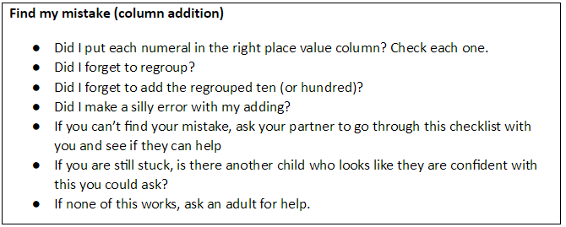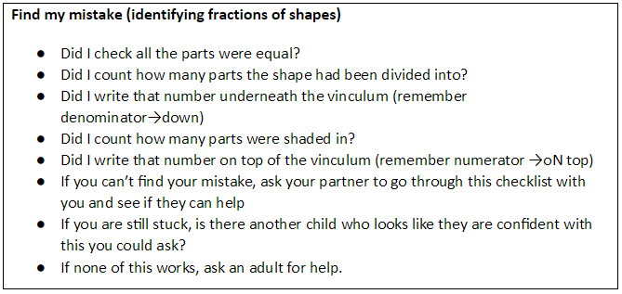
You can even use these for teaching at the start of the lesson. The lesson might, for example, feature the teacher deliberately getting a calculation wrong, before using the checklist to find their mistake. If there’s a TA in the room who can ham up playing the helpful partner, so much the better.
However you use them, it is key pupils internalise what they are doing (over the course of several lessons) so that they no longer need a written checklist. The aim is to get the checklist stored in their long-term memory. Giving pupils work to ‘mark’ from fictitious peers (with all the common mistakes) is a really good way of developing this.

Appendix 3- Whole Class Feedback Sheet
Whole class feedback sheet

Work to praise and share | Needs further support
Presentation | Basic skills error
Misconception and next lessons

