St. John the Baptist
RC Primary School

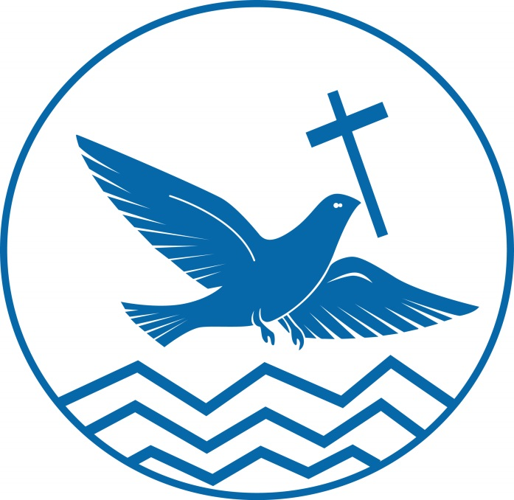

Collective Worship Policy
Approved | Autumn 19
Renew | Autumn 20

Collective Worship: policy and practice

Importance statement:
The daily act of collective worship at St. John the Baptist RC Primary School plays a central role in our life and work. It provides us with valuable opportunities to reaffirm our values and ethos. It offers important opportunities to strengthen our sense of community, belonging and inclusiveness and to reinforce the respect and care we have for each other. Through collective worship we make a significant contribution to the religious, spiritual, moral, social and cultural development of those present. Special festival worships, such as Harvest, Christmas and St John the Baptist are also held where members of the wider community are encouraged to attend. We want all our children/young people to ‘enjoy and achieve’ and collective worship provides a valuable vehicle for this.

We aim to:-
▪ Encourage children to recognise and express the feelings and senses from which worship naturally arises. In particular, the senses of beauty, wonder, pity, smallness, grandness, sadness, loss, peace, thoughtfulness, stillness and pride.
▪ Place worship in the centre of the children’s lives and in its rightful place in the curriculum. As such it will be planned like any other subject.
▪ Provide a wide variety of approaches towards worship, using any of the following to illustrate a point; music, The Bible, other literature and visual materials. This will aim to take into account the fact that we are all different and all have different preferences and needs.
▪ Involve all staff, if possible, as we believe that children need to be given as broad an experience of different types of worship as possible.
▪ Make staff, children and parents feel free to attend
▪ Provide an agreed, flexible programme of topics for collective worship on a termly basis
▪ Encourage children to take part in every possible way
▪ Include speakers from the wider community
▪ Be sensitive towards other faiths and encourage a free dialogue between the children emphasising that there is no element of one being better than another

These aims mean that our collective worship programme is such that we can include all our school community.
Practice
- Children are seated comfortably on the floor and listen quietly to music. A focus for worship (candle, picture, OHP) is usually provided.
- The children are asked to sit comfortably, eyes closed with their hands in their lap ready for prayer.
- Children are encouraged to take part in the prayers and are invited to respond to questions posed during the “story” part of worship.
- The majority of Acts of Worship are Christian based
- Within the worship a time of quiet and prayer is usually experienced
- The development of the spiritual nature of the child is seen as having great value and collective worship is used to promote this
- Parents are made aware in the School Prospectus that it is their right to withdraw their child from these acts of worship
The head teacher has the responsibility of ensure that the children are having a meaningful experience during collective worship and regularly reviews the process in conjunction with the Governors (ie regular review of policy)
Staff are encouraged to regularly attend Acts of Worship arranged for the children.

Collective worship and the law:
We comply with legal requirements by providing a daily act of collective worship for all pupils/students on the school roll, unless they have been withdrawn by their parent(s) ‘on grounds of conscience’. The majority of our acts of collective worship are ‘wholly or mainly of a broadly Christian character’ whilst recognising the religious, spiritual, moral, social and cultural insights provided by other principal religions and life-stances represented in Devon and in Great Britain.
.
Collective worship organisation:
- Use of the Bible and other sacred texts as a source for stories and teachings, emphasising common themes and ensuring the inclusiveness of the school community is reinforced. Moral tales/teachings and contemporary situations may also be drawn on where appropriate;
- Marking of appropriate festivals and other significant days;
- Opportunity for Christian children to pray ‘the Lord’s prayer’ as an important traditional Christian prayer periodically and that others listen to it respectfully together with our school prayer.

Whole school/key stage acts of collective worship:
- We aim to create an atmosphere of stillness and calm. To aid this, appropriate music is played for entry and exit from the hall.

- The usual format consists of an input from the leader, an appropriate hymn or song, followed by a time of prayer and/or quiet reflection. Leaders are encourage to actively engage pupils/students through for example questioning and drama;
- The act of collective worship is kept separate from any notices or other items which may be included in this assembly time, with a different person leading each section;
- Visitors may be invited from time to time to lead one of our whole school acts of collective worship;
- The assembly, including the act of collective worship, usually takes 15 minutes altogether.
- Pupils regularly lead whole school worship.
- Ten: Ten Resources can be used to plan worship on a Tuesday or a Wednesday as this online resource follows the same theme as the Sunday Gospel and Monday Liturgy.

Class-based acts of collective worship:
- We aim to give our children/young people some ‘space’ to be quiet and to think reflectively during collective worship in their classroom;
- These acts of collective worship may be led by the class teacher or by one or more of the pupils/students;
- They usually take 10-15 minutes.

Use of Visitors
The co-ordinator is responsible for liaising with any visitors who come into school to lead collective worship. Practical arrangements such as timing, age range of audience and appropriate content are agreed through discussion. By drawing on people from the local community to lead acts of collective worship we enhance community cohesion.

Health, Safety and Well-being
In collective worship we follow the school’s health, safety and well-being policy. For example, appropriate care must be taken when using lighted candles and electrical equipment. In line with our ‘net-safety’ policy any internet resources used must be checked by the leader prior to their use in act of collective worship. In the event of fire all pupils must be familiar with exit routes from the halls and other areas of the school where collective worship takes place. Visitors are not left unaccompanied with children/young people.
Equal Opportunities and Inclusion
Collective worship will challenge stereotypes, misinformation and misconceptions about race, ethnicity, religion and gender. During collective worship, religions will be presented fairly and accurately and diversity and equality will be affirmed.
Resources
A range of resources, including age-appropriate DVD material and PowerPoints, is available to support teachers and pupils with collective worship and is situated in the RE cupboard.

Appendix 1
Organisation of Collective Worship
Monday | Liturgy based upon Sunday Gospel
Tuesday | Development of the theme/link to God Matters /PSHE theme- Class worship
Wednesday | Development of the theme/link to God Matters /PSHE theme(whole school)
Thursday | Worship by song
Friday | Celebration act of worship

Appendix 2
GOD MATTERS: UNIT DATES 2019/2020
The dates given below are approximate and may need to be adapted to local circumstances.
UNIT | DATE | TEACHING TIME
AUTUMN TERM 2019
Creation | Start of Term | 4 weeks
Prayers Feasts and Saints | 07.10.19 | 2 Weeks
Half term 21.10.19
Islam | 29.10.19 | 1 Week
Sacraments | 04.11.19 | 4 Weeks
Advent | 02.12.19 | 2 weeks
Christmas | 16.12.19 | 1 week
SPRING TERM 2020
Feasts of Christmas - Epiphany | Start of Term | 2 weeks
Revelation | 20.01.20 | 4 Weeks
Half Term 17.02.20
Judaism | 25.02.20 | 1 week
Lent | 02.03.20 | 3 weeks
Holy Week | 23.03.20 | 1 week
SUMMER TERM 2020
Easter | 14.04.20 | 4 weeks
Pentecost and Mission | 11.05.20 | 2 weeks
Half Term 25.05.20
Pentecost and Mission | 02.06.20 | 2 weeks
Sikhism | 15.06.20 | 1 week
Hinduism | 22.06.20 | 1 week
Big Questions of Faith  Project RE e.g.  Going Back to Areas of Concern  Retreat/Pilgrimage Experiences | 29.06.20 | Until End of Term

Please see below for specific dates for the Liturgical Year; Feasts and Saints’ Days; Holy Days of Obligation; CAFOD dates; significant dates for other faiths.

SEPTEMBER | NEW BEGINNINGS
1st September to 4th October | Pope Francis’ Season of Creation https://catholicclimatemovement.global/ and http://seasonofcreation.org/
Ordinary Time
8th September | Education Sunday https://www.catholiceducation.org.uk/schools/education-sunday
14th September | Exaltation of the Cross – opportunity to explore why we make the sign of the cross
15th September | Home Mission Sunday
21st September | St. Matthew – Evangelist  International Day of Peace
Late September | Harvest
27th September | St. Vincent de Paul
OCTOBER | MONTH OF THE ROSARY
1st October | St. Therese of the Child Jesus
2nd October | The Holy Guardian Angels
4th October | St. Francis of Assisi  CAFOD Brighten Up for Harvest Day/CAFOD Harvest Fast Day https://cafod.org.uk/News/Events/Harvest-Fast-Day
7th October | Our Lady of the Rosary
8th October | Yom Kippur
15th October | St. Teresa of Avila – Doctor of the Church
16th October | World Food Day
17th October | International Day for the Eradication of Poverty
18th October | St. Luke the Evangelist  One Million Children Praying the Rosary http://millionkidspraying.org/
27th October | Diwali
NOVEMBER | MONTH OF REMEMBRANCE FOR THOSE WHO HAVE DIED
1st November | All Saints
2nd November | All Souls
9th November | Dedication of the Lateran Basilica
17th November | World Day of the Poor
19th November | World Toilet Day
24th November | Christ the King – Solemnity  Universal Children’s Day
24th November | Christ the King
30th November | St. Andrew – patron Saint of Scotland
DECEMBER
Advent of Beginning of the new liturgical year: YEAR C
1st December | First Sunday of Advent
6th December | St. Nicholas
9th December | Immaculate Conception – Feast
18th December | International Migrants Day
JANUARY
Christmastide until Baptism of the Lord
1st January | Mary Mother of God  World Day of Peace
5th January | Epiphany – HOLY DAY OF OBLIGATION
12th January | Baptism of the Lord
Ordinary Time
25th January | Conversion of St. Paul
28th January | St. Thomas Aquinas
FEBRUARY
2nd February | Presentation of the Lord – Feast of Candlemass
20th February | World Day of Social Justice
24th February | Fairtrade fortnight begins http://www.fairtrade.org.uk/en/get-involved/current-campaigns/fairtrade-fortnight
25th February | Shrove Tuesday
Lent
26th February | Ash Wednesday
MARCH
1st March | St. David – patron Saint of Wales  First Sunday of Lent
6th March | CAFOD Lent Fast Day
17th March | St. Patrick – patron Saint of Ireland
19th March | St. Joseph, husband of the Blessed Virgin Mary
20th March | International Day of Happiness
22nd March | World Water Day  Fourth Sunday of Lent
24th March | St Oscar Romero https://cafod.org.uk/Education/Primary-teaching-resources/St-Romero
25th March | Annunciation of the Lord
APRIL | EASTERTIDE
5th April | Palm Sunday
8th April | Passover begins
9th April | Maundy Thursday
10th April | Good Friday
11th April | Holy Saturday
12th April | Easter Sunday
Eastertide
13th April | Vaisakhi
19th April | Divine Mercy Sunday
22nd April | Earth Day
23rd April | Ramadan begins
23rd April | St. George – patron saint of England
25th April | St. Mark – Evangelist
29th May | St. Catherine of Siena
MAY | MONTH OF MARY
1st May | St. Joseph the Worker
7th May | Wesak
14th May | St. Matthias, Apostle - Feast
21st May | Ascension of the Lord - HOLY DAY OF OBLIGATION
23rd May | Ramadan ends
31st May | Pentecost
JUNE
Ordinary Time
1st June | Mary, Mother of the Church
5th June | World Environment Day
7th June | The Most Holy Trinity
14th June | Corpus Christi
15th June | World Refugee Week begins https://globaldimension.org.uk/event/refugee-week-2/2020-06-15/
22nd June | St. John Fisher and St. Thomas More – Martyrs - Feast
23rd June | Eid al Fitr
24th June | Birth of St. John the Baptist
28th June | Ss. Peter and Paul – HOLY DAY OF OBLIGATION
JULY | THANKSGIVING AND MOVING ON
3rd July | St. Thomas
11th July | St. Benedict - Feast
18th July | Nelson Mandela Day https://globaldimension.org.uk/event/nelson-mandela-international-day/2019-07-18/

