Year 4, 5 and 6 RE Focus – Pentecost Serving

This term our RE focus is Pentecost - Serving
The children’s Big Question is: What do I want to witness to in my life?
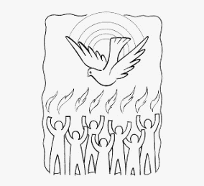
The children will be reflecting on this and asking: Why does it sometimes need courage to be a witness? What is a ‘modern witness’?
Together they will be exploring: The courage to be a witness. Pentecost: The Holy Spirit enables people to witness to the Easter

They will be reading relevant scriptures: Luke 24: 44-49, Matthew 28: 16-20, Acts 1: 6-14, Acts 6: 6 – 7: 6, Acts 16: 11-15 , Ephesians 2: 10
They will also be exploring the following themes which we encourage you to discuss with them at home:
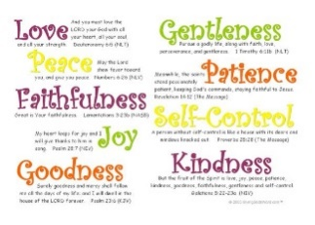 | Holy Spirit  The Holy Spirit is our helper, teacher, comforter, and our friend! We can see The Holy Spirit in the joy, the courage and the strength that it gives. The Holy Spirit inspires us with good ideas and its gifts helps us to carry them out.
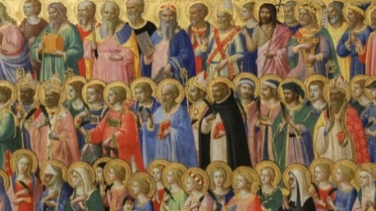 | Martyrs: A martyr is a person to have died because of their testimony for Jesus or faith in Jesus.

Key Vocabulary

witness, Holy Spirit, Witnesses, martyrs, courage, truth, inspiration, Good News

