Prayer at St Johns
Prayer is central to our life as a Catholic School. We pray regularly throughout the school day either in classes or as a whole school.
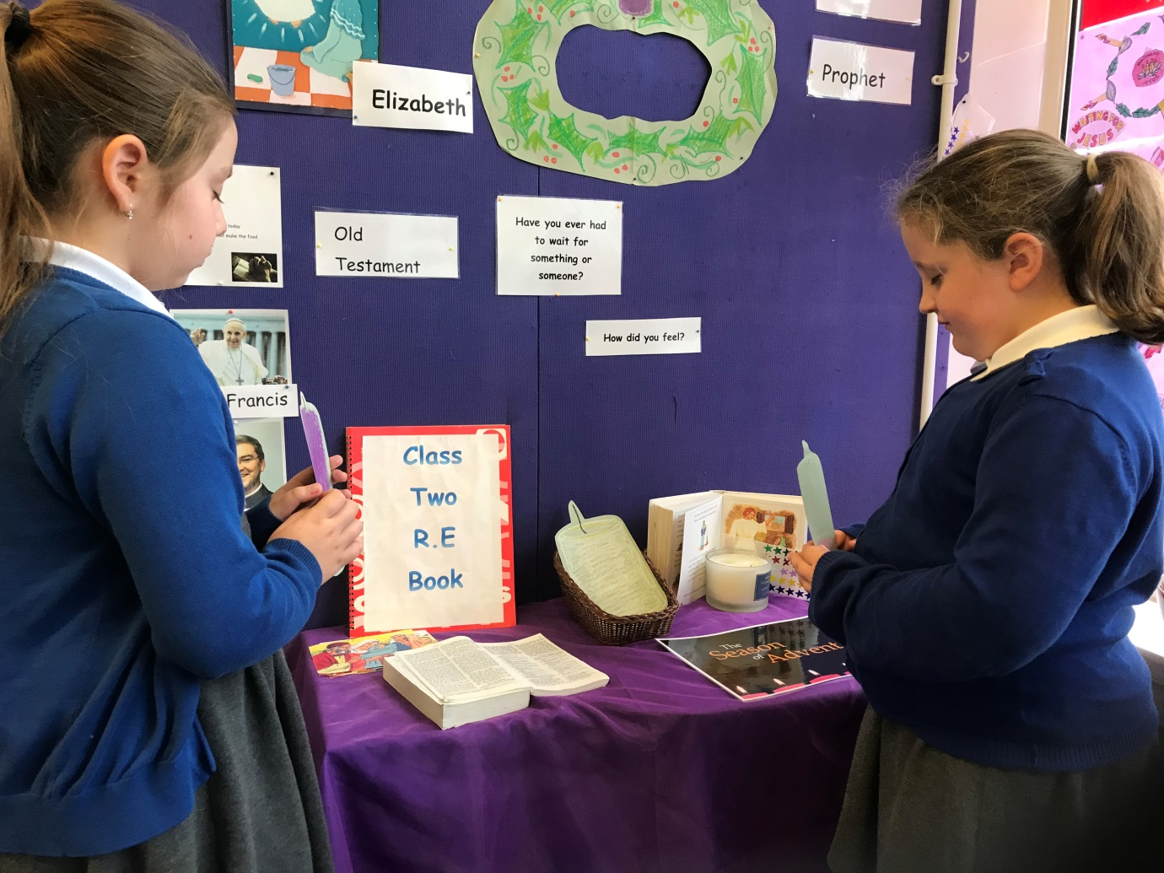

Sign of the Cross
In the Name of the Father, And of the Son and of the Holy Spirit
Amen.

Morning Prayer
Father in Heaven you love me
You’re with me Night and Day
I want to Love you always
In all I do and Say
I’ll try to please you Father
Bless me through the Day
Amen

Our Father
This is how Jesus told us we should pray:
Our Father which art in heaven, Hallowed be thy name.
Thy kingdom come. Thy will be done in earth, as it is in heaven.
Give us this day our daily bread.
And forgive us our debts, as we forgive our debtors.
And lead us not into temptation, but deliver us from evil: For thine is the kingdom, and the power, and the glory, for ever. Amen.
Hail Mary
Hail Mary, full of grace, the Lord is with thee; blessed art thou among women, and blessed is the fruit of thy womb, Jesus. Holy Mary, Mother of God, pray for us sinners, now and at the hour of our death. Amen.
Glory Be
Glory be to the Father, and to the Son, and to the Holy Spirit, as it was in the beginning, is now, and ever shall be, world without end.
Body prayer
What are Body Prayers?
Body prayers are a way of talking to God with our bodies rather than with words. In the same way that we wave hello or we give someone a hug, body prayers are a way of expressing ourselves to God through our movements.
Why are Body Prayers useful for children?
Body Prayers are great for children because they love to move! They can help children to see the fun side of praying and give the opportunity for kinaesthetic and visual learners to feel fully included and involved in a prayer time.

I see God in the Sky above
I see God in the ground below
I see God in the sea
I see God in you and me.

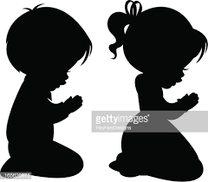
Examen
A Jesuit resource, developed by Ten:Ten Resources. We have started to use a reflective type of prayer called The Five-Day Examen.
Based on the traditional Ignatian meditation, this resource has been specially adapted so it can be used by class teachers at the end of each school day in a simple way to create a prayerful and reflective atmosphere. Children reflect on what has gone well in their day and what they want to work on the next day.
