Year EYFS and Year 1 RE Focus – Pentecost Serving

This term our RE focus is Pentecost - Serving
The children’s Big Question is: “What is good news?”
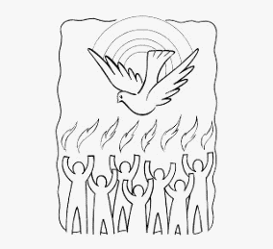
The children will be reflecting on this and asking: What is Good News? What happened on Pentecost day?
Together they will be exploring ‘That everyone has good news and talk about and wonder how they feel about good news to share. They will talk about the celebration of the Good News of Jesus and be able to recognise and talk about the good news of the Holy Spirit and Pentecost.’
They will be reading relevant scripture- Acts 2: 1-4 and their prayer focus will be the Alleluia and a Litany of Praise. They will also be exploring the following themes which we encourage you to discuss with them at home:
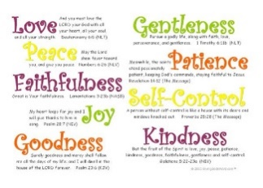 | Holy Spirit  The Holy Spirit is our helper, teacher, comforter, and our friend! We can see The Holy Spirit in the joy, the courage and the strength that it gives. The Holy Spirit inspires us with good ideas and its gifts helps us to carry them out.
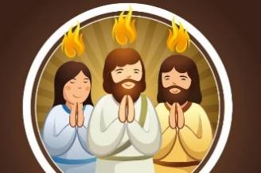 | Pentecost  Pentecost is celebrated 50 days after Easter and is when Christians remember the gift of the Holy Spirit. The Holy Spirit is the third part of the Trinity - Father, Son and Holy Spirit.
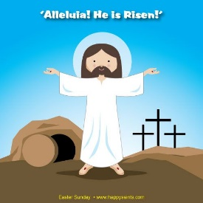 | Alleluia  Means “Praise God!” A song to praise God with joy, especially at Easter.

Key Vocabulary
good news, share, Good News, Pentecost, promise, Holy Spirit, Easter, alleluia

